GITHUB LINK: https://github.com/knishalini1497/DSA0101-192521301-ASSIGNMENT-1
https://github.com/knishalini1497/DSA0101-192521301-ASSIGNMENT-1/blob/main/README.md
TASK GITHUB CODE: https://special-eureka-wrp7x5j57pjjhxvp.github.dev/
TASK-1 - DSA0101-192521301-ASSIGNMENT-1 [Codespaces: special eureka] - Visual Studio Code

TASK 1
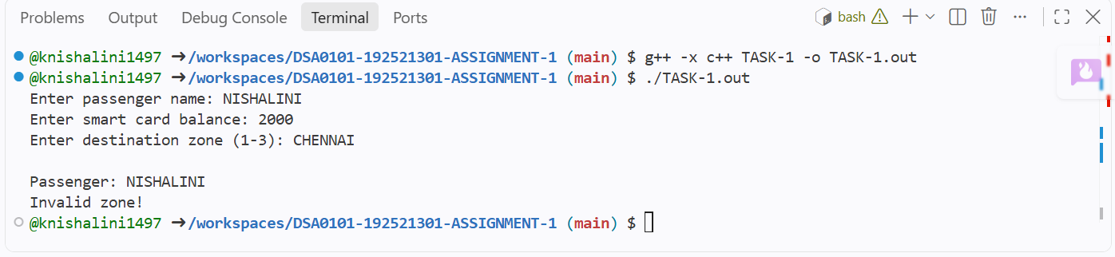

TASK 2
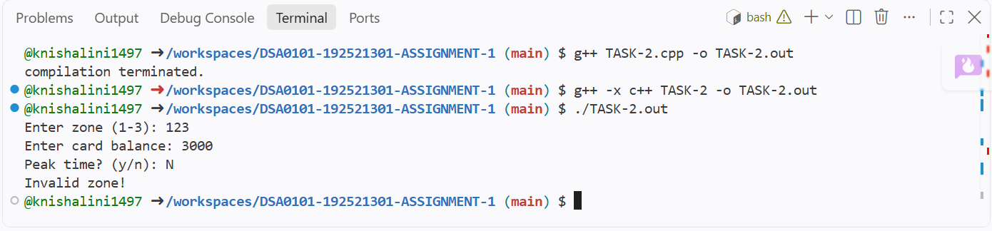

TASK 3
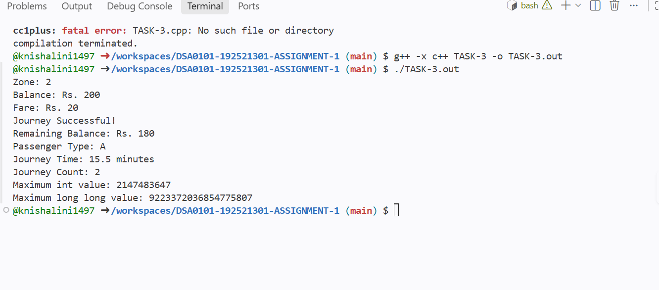

TASK 4
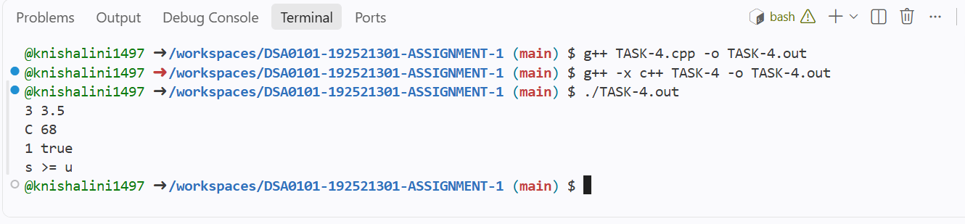
TASK 5
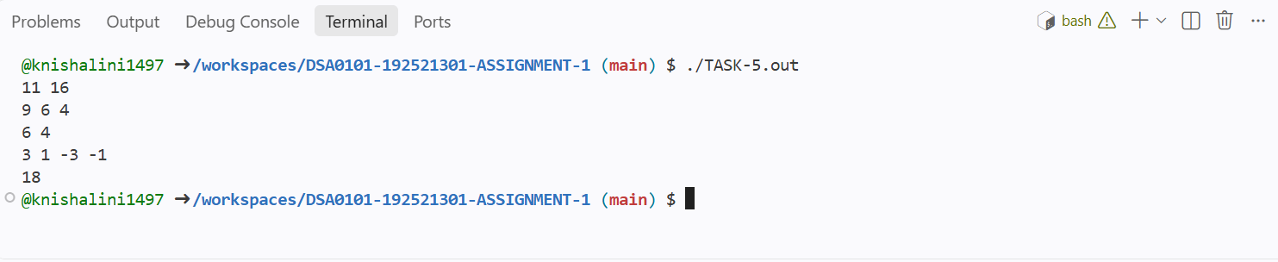

TASK 6
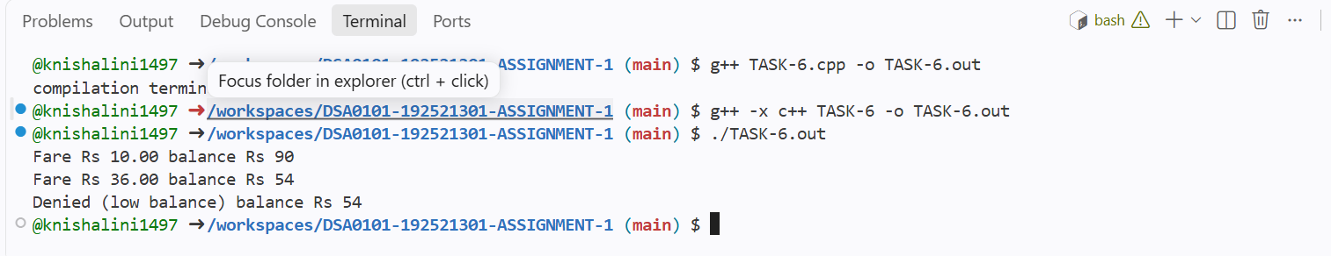

TASK 7
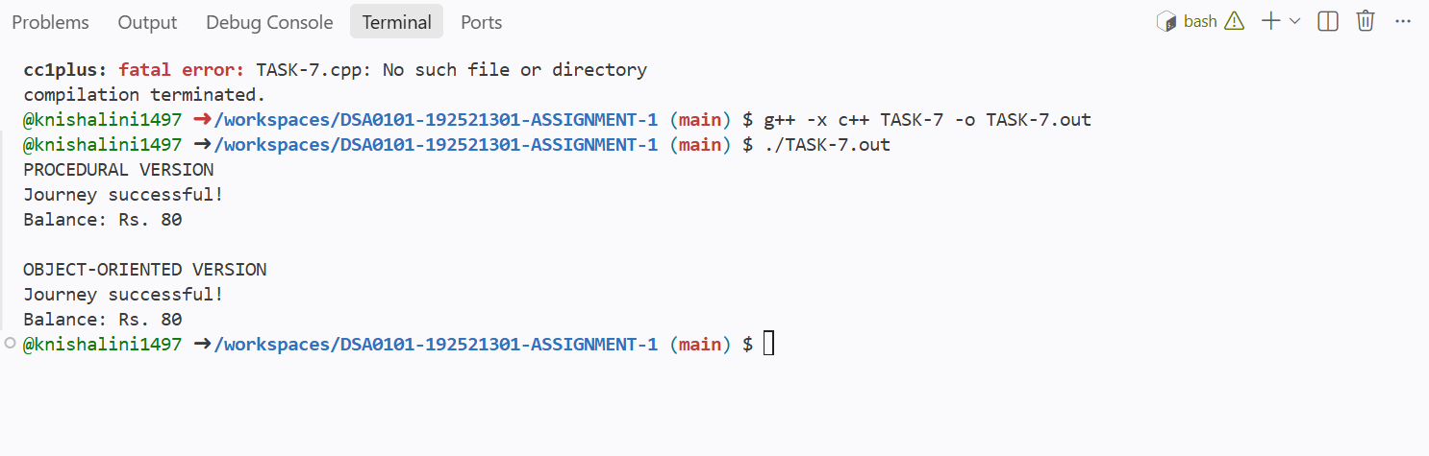

TASK 8
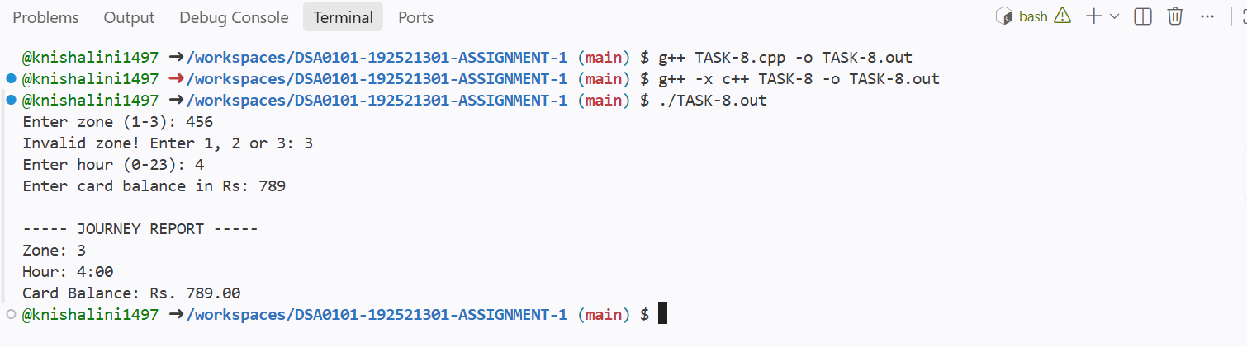

TASK 9
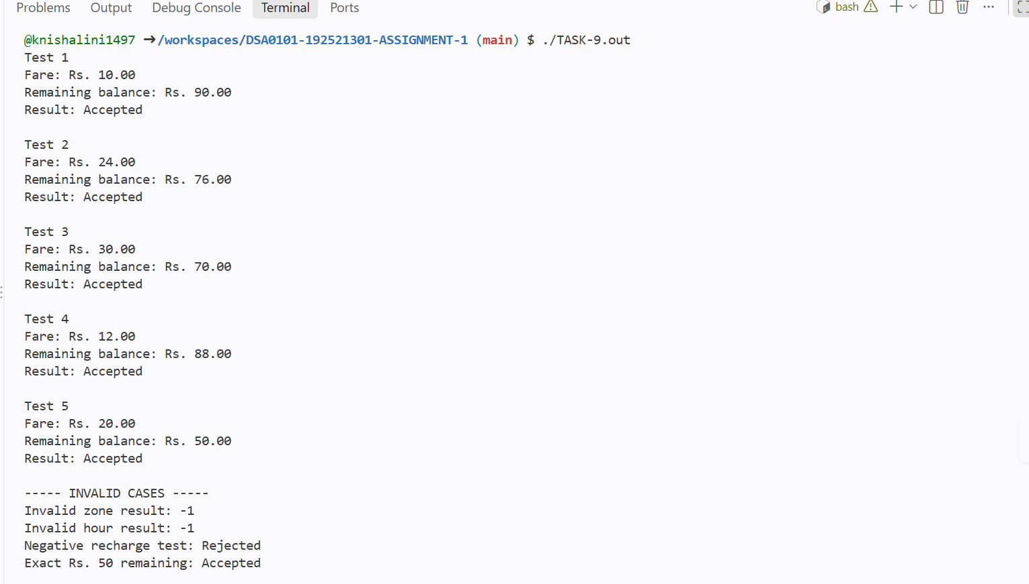
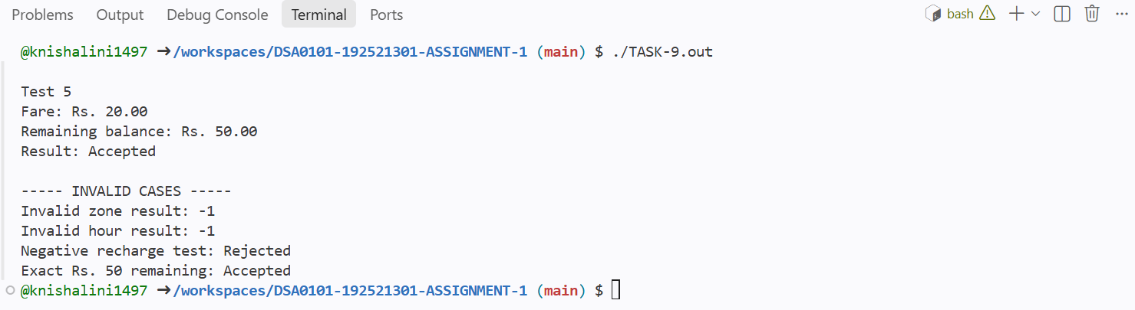

TASK 10
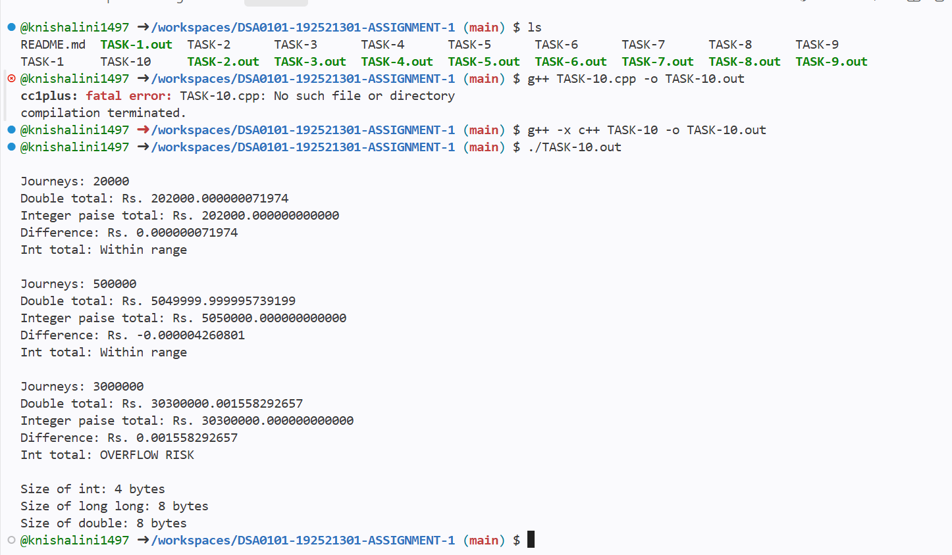

TASK 11
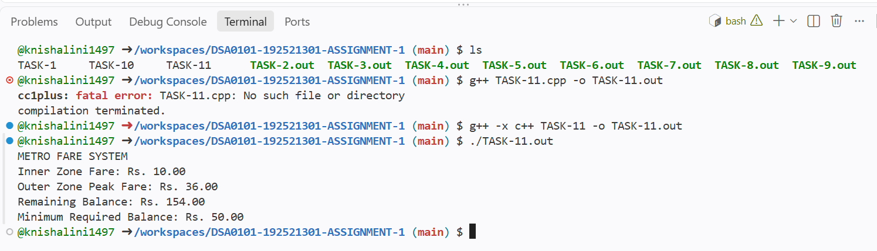

TASK 12


